# Team Name - 4The People

**Team Leader - Swathi Anandram**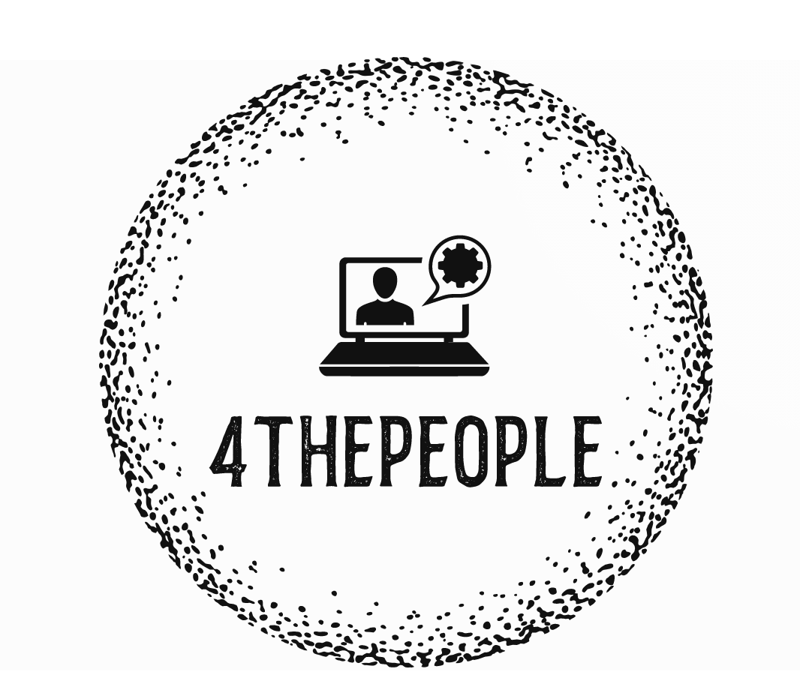

**Project Idea -**

Abstract -

**Team Members -**Swathi Anandram  
Harika Nalam

Supreetha M A

Aryan Jadon

**Github Repo Link -**

<https://github.com/aryan-jadon/SJSU-Enterprise-Application>